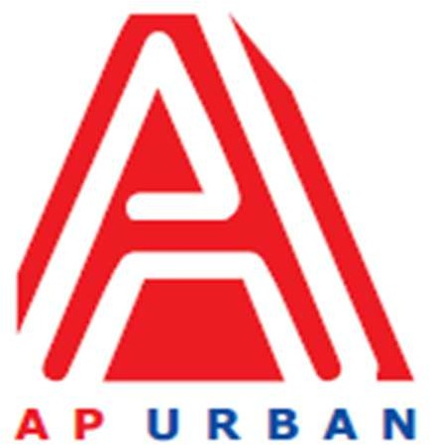

Andhra Pradesh Urban Infrastructure Asset Management Limited

4th Floor, NTR Administrative Block, Pandit Nehru Bus Station, Vijayawada - 520 013 Website: [www.apurban.com](http://www.apurban.com/)

HUMAN-RESOURCE REQUIREMENT NOTIFICATION (HRN)

UNDER Swachha Andhra Corporation – Project Management Unit

|  |  |  |
| --- | --- | --- |
| **S. No.** | **Particulars** | **Description** |
| **1** | **Position** | Deputy Project Manager |
| **2** | **No. of Position** | One (01) |
| **3** | **Proposed Grade** | Sr. Officer |
| **4** | **Mode (Consultant /**  **Employee)** | Consultant |
| **5** | **Academic / Professional Qualifications** | Any Degree or Post Graduation with Good Communication Skills |
| **6** | **Post qualification**  **experience (specific requirement)** | Minimum 4 to 6 years of experience in Project Coordination, management, client interactions, team coordination and having knowledge about Solid and Liquid waste management.  Experience in working with Government organizations would be desirable.   1. Excellent oral and written communication skills 2. Strong working knowledge of MS Office is mandatory–report writing/data analysis /Presentation experience. 3. Dissemination of national/state/ULB/district level campaigns regarding various components of SBM Urban & Grameen, including interpersonal communication. 4. Support in empanelment and engagement of various stakeholders for grassroots mobilization and sensitization regarding SBM. 5. Organization of promotional events (such as competitions, triggering activities etc.) and campaigns social media. |
| **7** | **Reporting to** | Project Manager/FH/DH |
| **8** | **Salary / Fee range** | As per Industry Standards |
| **9** | **Other expectations** | Late working depending on urgency of work to be done / meeting  delivery timelines & travelling on need basis |
| **10** | **Scope of Work**  **(If taking for more than a project, then write Project wise SoW)** | 1. Gather accurate and reliable data and analyze/interpret the same. 2. Prepare work plan for ULBs and evaluate the implementation of the work plan. 3. Provide technical support to ULBs 4. Provide structures and mechanism regarding implementation of SBM 2.0 in the state of Andhra Pradesh. |
| **11** | **Core Skills** | Good Communication Skills and Knowledge on Municipal Solid Waste Management preferable |
| **12** | **Gender specific, if any** | Neutral |
| **13** | **Location** | Vijayawada |
| **14** | **Any other point, you would like to mention** | It is desirable that the candidates would have prior experience of  working with government. Preferably resident of Andhra Pradesh.  Telugu Language is desirable. |

**Note:** Apply for the above said position through **Standard CV Format** (to download Click here) along with detailed CV and send at : **jobs@apurban.in** (properly mention position name in subject line)