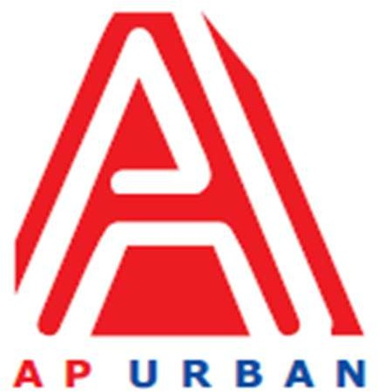

Andhra Pradesh Urban Infrastructure Asset Management Limited

4th Floor, NTR Administrative Block, Pandit Nehru Bus Station, Vijayawada - 520 013 Website: [www.apurban.com](http://www.apurban.com/)

MANPOWER REQUIREMENT NOTIFICATION (MRN)

UNDER Food and Enterprise Development Division of APUIAML

For Tourism PMU

(Position Ref. No. 4)

|  |  |  |
| --- | --- | --- |
| **S. No.** | **Particulars** | **Description** |
| **1** | **Position** | Civil Engineer |
| **2** | **No. of Position** | One (01) |
| **3** | **Proposed Grade** | Officer / Senior Officer |
| **4** | **Mode (Consultant /**  **Employee)** | Project Associate |
| **5** | **Academic / Professional Qualifications** | * Bachelor of Civil Engineering (Civil) * Preference shall be given to candidates from Premier Institutions |
| **6** | **Post qualification**  **experience**  **(Specific**  **requirement)** | * + Minimum 3 years of experience, preferably worked for Government Projects / Consulting   + Design, supervision and implementation of infrastructure projects. This includes hands-on involvement in site investigations, preparation of engineering drawings and BOQs, project planning, and construction supervision. Experience has been gained across [mention sectors: e.g., tourism, urban development, road works, or water infrastructure] with a focus on quality control, safety compliance, and sustainable design practices. |
| **7** | **Reporting to** | F&ED Head /DH |
| **8** | **Salary / Fee range** | As per Industry Standards |
| **9** | **Other expectations** | * + Flexibility in working hours depending on urgency of work / delivery timelines   + Flexibility in traveling |
| **10** | **Scope of Work**  **(If taking for more than a project, then write Project wise SoW)** | **Site Assessment & Feasibility Analysis:** Conduct technical site investigations for proposed tourism infrastructure (e.g., access roads, resorts, visitor centres, trails, piers), Collaborate with architects, environmental experts, and tourism planners during pre-feasibility and feasibility studies, Evaluate terrain, environmental risks, utilities availability, and construction viability.  **Design & Engineering Support:** Prepare and/or review engineering drawings, technical specifications, and BOQs, incorporate sustainable and climate-resilient design principles, Ensure compliance with national building codes, tourism standards, and accessibility guidelines.  **Project Planning & Procurement:** Provide input into project implementation plans, budgets, and timelines, assist in preparing tender documents (TORs, drawings, specs) for contractors and suppliers, Support the evaluation of bids and selection of construction firms.  **Construction Supervision & Quality Control:** Monitor construction activities on-site for compliance with design, safety, and quality standards, Coordinate with contractors, suppliers, and local authorities, maintain project documentation, including daily reports, variation orders, and testing records. |
| **11** | **Core Skills** | * + Proficient in AutoCAD, Civil 3D, MS Project/Primavera   + Excellent oral and written communication skills   + Strong working knowledge of MS Office – Word, PowerPoint, Excel   + Report writing /Presentations   + Knowledge of GIS   + Multi-tasking   + Research & Analysis |
| **12** | **Gender specific, if any** | Neutral |
| **13** | **Location** | Vijayawada (Andhra Pradesh) |
| **14** | **Any other point, you would like to mention** | It is desirable that the candidates would have prior experience of  working with government. |

**Note: Apply for the above said position through Standard CV Format (available at our website:** [**www.apurban.com/careers.php**](http://www.apurban.com/careers.php)**) along with detailed CV and send at: jobs@apurban.in (properly mention position name in subject line)**