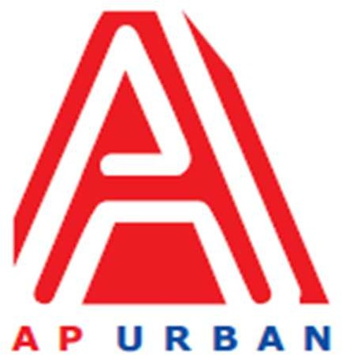

Andhra Pradesh Urban Infrastructure Asset Management Limited

4th Floor, NTR Administrative Block, Pandit Nehru Bus Station, Vijayawada - 520 013 Website: [www.apurban.com](http://www.apurban.com/)

MANPOWER REQUIREMENT NOTIFICATION (MRN)

UNDER Food and Enterprise Development Division of APUIAML

For Tourism PMU

(Position Ref. No. 3)

|  |  |  |
| --- | --- | --- |
| **S. No.** | **Particulars** | **Description** |
| **1** | **Position** | Planner |
| **2** | **No. of Position** | One (01) |
| **3** | **Proposed Grade** | Officer/Senior Officer |
| **4** | **Mode (Consultant/**  **Employee)** | Consultant |
| **5** | **Academic / Professional Qualifications** | * Master in Planning or Architecture or Equivalent with excellent communication (Writing & Speaking) skills * Preference shall be given to candidates from Premier Institutions |
| **6** | **Post qualification**  **experience**  **(Specific**  **requirement)** | * + Minimum 1 years of experience, work experience in Government Projects /Consulting   + Development of master plans, zoning ordinances, and regional policies.   + Conducted demographic, economic, and land-use analyses.   + Collaboration with municipal governments on urban development projects.   + Conducted Data Collection / Research / Analysis, Site Due Diligence, Market Assessment   + Report Writing (Concept Notes, Feasibility Reports, Project Reports, DPRs etc.)   + Work with the team, Preparation of Flyers, Presentations   **Key Skills:**   * + Excellent oral and written communication skills   + Strong working knowledge of MS Office – Word, PowerPoint, Excel   + Report writing /Presentations   + Knowledge of GIS & AutoCAD,   + Multi-tasking   + Research & Analysis |
| **7** | **Reporting to** | F&ED Head /DH |
| **8** | **Salary / Fee range** | As per Industry Standards |
| **9** | **Other expectations** | * Flexibility in working hours depending on urgency of work / delivery timelines * Flexibility in traveling |
| **10** | **Scope of Work**  **(If taking for more than a project, then write Project wise SoW)** | * + Development of master plans, zoning ordinances, and regional policies.   + Conduct demographic, economic, and land-use analyses.   + Collaboration with various governments clients on urban development projects.   + Conduct Data Collection / Research / Analysis, Site Due Diligence, Market Assessment   + Report Writing (Concept Notes, Feasibility Reports, Project Reports, DPRs etc.)   + Work with the team, Preparation of Flyers, Presentations   + Support Team / Colleagues for timebound deliverables   + Client Co-ordination |
| **11** | **Core Skills** | * + Report Writing, Presentations   + Arc GIS (Advanced);   + Q-Gis;   + Sketch up;   + Auto CADD ;   + PTV (Vissim);   + Adobe Photoshop, Premiere Pro;   + Google earth;   + MS-office |
| **12** | **Gender specific, if any** | Neutral |
| **13** | **Location** | Vijayawada (Andhra Pradesh) |
| **14** | **Any other point, you would like to mention** | It is desirable that the candidates would have prior experience of  working with government. |