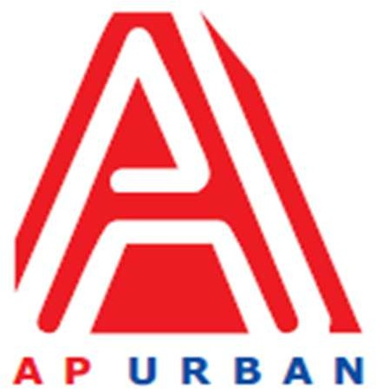
Andhra Pradesh Urban Infrastructure Asset Management Limited
4th Floor, NTR Administrative Block, Pandit Nehru Bus Station, Vijayawada - 520 013 Website: www.apurban.com

MANPOWER REQUIREMENT NOTIFICATION (MRN) FORM

S. No. | Particulars | Description
1 | Position | Consultant - UID & PPP
2 | No. of Position | 1 (One)
3 | Proposed Grade | Manager / Sr Manager
4 | Mode (Full Time / Part Time) | Full Time
5 | Academic / Professional Qualifications | - Engineer (BE / B.Tech) / Architect / Planner (Urban Planning / Infrastructure Planning / Urban Design), MBA (Preferred)
6 | Post qualification  experience (specific requirement) | Minimum 8-10 years in Transaction Advisory Consultancy
7 | Reporting to | Divisional Head – UID & PPP
8 | Scope of Work  (If taking for more than a project, then write Project wise SoW) | - Business Development  - Preparation of Feasibility Reports / DPRs  - Carrying out market assessments  - Knowledge of financial modeling  - Preparing Presentations  - Bid Documents preparation for PPP Projects  - Bid Process management
9 | Skill requirement  - Major  - Minor | - To carry out site visits as & when required for project sites,  To carry out research in specific or general project areas,  To Interpret and apply applicable state, county and local codes, ordinances and regulations for the all the projects,  Assist in preparation of plans, reports Project information dossiers, presentations etc.by analyzing various data,  Preparation of various project reports utilizing the skills of architecture, urban planning & infrastructure development concepts,  Client Co-ordination and correspondence  - Experience in Transaction Advisory Consultancy for PPP Projects (market assessment / feasibility reports / Bid Documents / Bid Process management), DPRs for Infrastructure Projects for Central Funding Assistance
10 | Gender specific, if any | Neutral
11 | Location | Vijayawada
12 | Any other point, you would like to mention | Late sitting depending on urgency of work to be done / meeting delivery timelines, Client Interaction & travelling on need basis. Preferably Telugu language

Note:
Apply for the above said position through Standard CV Format (to download Click here) along with detailed CV and send at : jobs@apurban.in (properly mention position name in subject line)

